
ICT Support Officer
Grade 6

Our Vision
An innovative, ambitious and sustainable county, where everyone has the opportunity to prosper, be healthy and happy.

Our Outcomes
We want everyone in Staffordshire to:
- Have access to more good jobs and share the benefit of economic growth
- Live in thriving and sustainable communities
- Be healthier and more independent for longer

Our Values
Our People Strategy sets out what we all need to do to make Staffordshire County Council a great place to work, where people are supported to develop, flourish and contribute to our ambitious plans. Our values are at the heart of the Strategy to ensure that the focus is on what is important to the organisation and the people it serves:
- Ambitious – We are ambitious for our communities and citizens
- Courageous – We recognise our challenges and are prepared to make
courageous decisions
- Empowering – We empower and support our people by giving them
the opportunity to do their jobs well.
About the Service
Staffordshire ICT defines and delivers an ICT strategy that is directed by the ambitions of the County Councils Strategic Plan and in year Business Plans.
The ICT strategy defines how Staffordshire County Council will exploit to best effect its use of Information and Communication technology with particular emphasis on how “Digital Transformation” can enable the Council to deliver services in a fundamentally different way that radically transforms Citizen Interactions and the delivery of services in a digital era.
Such transformational change embracing cloud computing, mobile working and Information sharing requires strong leadership to understand and remodel cross organisational service delivery focussing on the whole system and designing this from a citizen perspective. Inevitably such change calls for complex change management and negotiation skills to ensure successful and integrated delivery across public sector partners and private sector supplier organisations.
Whilst the role of ICT in digital transformation is critical to long term organisational success and sustainability, the ICT function must also ensure that its delivery of the core ICT service is efficient, secure and reliable as the impact of technological or cyber security related failure is catastrophic to the productivity of the organisation. Robust management of ICT services and in particular the effectiveness of Cyber Security defences is paramount to the effective delivery of the councils’ legislative responsibilities.
ICT Architecture, operations and Service delivery
This area of the ICT service is responsible for the operation of the council ICT Infrastructure, this includes the Data Centre Infrastructure that runs all of the councils primary business applications such as our Social Care system or the hundreds of other Business applications that are delivered January 2021 JD/PS JD/PS template locally allowing staff to deliver statutory responsibilities. The security of council data through backup and replication solutions and the routine testing of ICT Disaster recovery arrangements is also a key responsibility of this service area.
The service manages, on behalf of the wider Staffordshire Public Sector, the Staffordshire Public Services network that means that council staff, NHS staff, Fire and Rescue staff and District\Borough council staff can all perform their critical roles accessing a variety of ICT resources and increasingly sharing intelligence and services over this exemplar shared service capability.
Operationally this is very much a 365 x 24 operation and a range of “on-call” arrangements are in place to ensure that operational availability is maximised and disruption to council or wider Public Sector operations is minimised.
Inevitably the complexities of such environments require careful planning to ensure that changes and future demands are met, validated, documented and planned into design documents, change proposals and projects to ensure that the services delivered are fit for purpose, compliant with stringent security demands and don’t compromise the operational availability of services. The function therefore includes an Architectural team that validates technical changes and plans, be they driven through new service demands, increased utilisation, compliance, risk reduction, cost reduction or any other driver. The constant demand for ICT related change and the need to maintain security compliance means that this small team are critical to the sustained availability of services working closely with operational teams to ensure that deployment is authorised and implemented effectively.
The Service Delivery team support the council’s workforce of staff, volunteers and subcontracted partners to ensure that they can optimally access ICT services using the best technology to meet their needs and access support should they experience any difficulties. The team manage the routine refresh of end user computer technology including mobile devices and associated software.
The operational security team is responsible for maintaining compliant software using tools to ensure that security defences such as Anti-Virus software, supplier patches, encryption and authentication are constantly maintained to agreed standards. The team work with subcontracted suppliers and act on threat intelligence and logging data to reduce the risk of compromise to ICT services or the loss of council data through theft, loss or destruction. With the ever-increasing demand to transact in a “digital” way the Security and Architecture teams manage the operational risks of delivering this in a compliant and secure way

Reporting Relationships
Responsible to: Team Leader
Responsible for: N/A
Key Accountabilities:
This post works across Staffordshire County Council (SCC) and the ICT community. It is primarily responsible for the provision of 1st and 2nd line ICT support providing efficient problem resolution, advice and support to customers, supporting ICT applications, end user compute and network technologies. The post holder will make use of corporate standards, best practice and established industrial standards in order to achieve the objectives of the unit.
• Provide effective 1st and 2nd line ICT Support to the SCC user community resolving reported service issues and dealing with standard requests for change.
• Ensure that operational service levels are achieved and where required work in virtual teams to assist with the delivery of wider activities e.g., projects, problem management teams, task groups etc. to ensure continuous improvement to ICT services
• Communicate effectively with wider ICT teams and customers on any disruption to ICT service availability.
• Ensure that procedures in the areas of Problem, Incident, Change, Configuration and Release management are followed.
• Contribute to the delivery of Service improvements aligned to the delivery of the ICT Strategy and in year plan on a page.
• Keep abreast of improvements in relative ICT technologies e.g., end user computing, network technologies, operating system, applications, security technologies etc. through research, training and networking, highlighting and\or proposing further investigations where benefits and improvements can be made.
• Assist in the preparation, maintenance and testing of ICT Disaster Recovery procedures to ensure that the council can recover from a catastrophic event that impacts on the availability of ICT.
• Ensure that all inventories, asset registers, applications portfolios, customer databases, schematics, schedules and configurations are available and accurate to ensure that ICT services are fully documented, supported and recoverable.
• To participate in the full range of Departmental and County Council activities including corporate working groups and other initiatives as required from time to time.
• Such other duties as may arise in connection with the activities mentioned above
Professional Accountabilities:
The post holder is required to contribute to the achievement of the Council objectives through:
Financial Management
Personal accountability for delivering services efficiently, effectively, within budget and to implement any approved savings and investment allocated to the service.
People Management
Engaging with People Management policies and processes
Equalities
Ensuring that all work is completed with a commitment to equality and anti-discriminatory practice, as a minimum to standards required by legislation.
Climate Change
Delivering energy conservation practices in line with the Council’s climate change strategy.
Health and Safety
Ensuring a work environment that protects people’s health and safety and that promotes welfare, and which is in accordance with the Council’s Health & Safety policy.

Safeguarding
Commitment to safeguarding and promoting the welfare of vulnerable groups.
ICT responsibilities – SFIA Framework (Level 2 role)
The content of this Job Description and Person Specification will be reviewed on a regular basis.

Person Specification A = Assessed at Application
I = Assessed at Interview
T = Assessed through Test

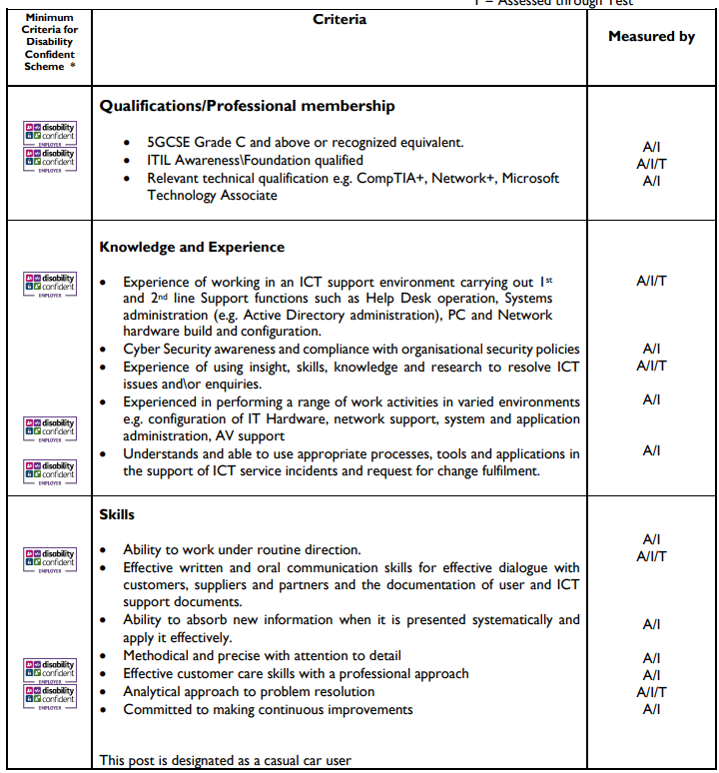 If a disabled person meets the criteria indicated by the Disability Confident scheme symbol and provides evidence of this on their application form, they will be guaranteed an interview.
We are proud to display the Disability Confidence Symbol, which is a recognition given by Job centre plus to employers who agree to meet specific requirements regarding the recruitment, employment, retention, and career development of disabled people.

If you need a copy of this information in large print, braille, another language on cassette or disc, please ask us by contacting
Talent & Resourcing Team 01785 278300

