

**Candidate Guide**

Recruitment & Selection

v1.0

Resourcing Team

Date

Monday, 03 October 2022

**01**

# Contents

**Introduction**

**Our values**

**Applying for our roles**

**Shortlisting**

**Interviews & assessment**

**Interview hints & tips**

**Equal Opportunities** –Disability Confident Employer, Armed

Forces Covenant Silver Award & Care Leavers

**Documentation**

**References**

**Rehabilitation of Offenders Act**

**Safer Recruitment**

**GDPR**

**Politically Restricted roles**

**Relationship to members / Employees canvassing**

**Cabinet Office Fair Processing Protocol**

**02**

# Introduction

We’re delighted you’re considering a career here at Staffordshire County Council!

Our people are key to our success as an organisation, so we have set up our recruitment processes to be inclusive and hopefully attracting the widest number of candidates as possible. And where any support or adjustments may be needed, we highlight these too.

This Candidate Guide gives useful information about our recruitment processes, plus hints and tips to make your candidate journey with us a pleasant one.

Plus, if there’s anything you think we can do better in future do let us know at talent@staffordshire.gov.uk

Contents

# Our values

Here at Staffordshire, we have 3 key values:

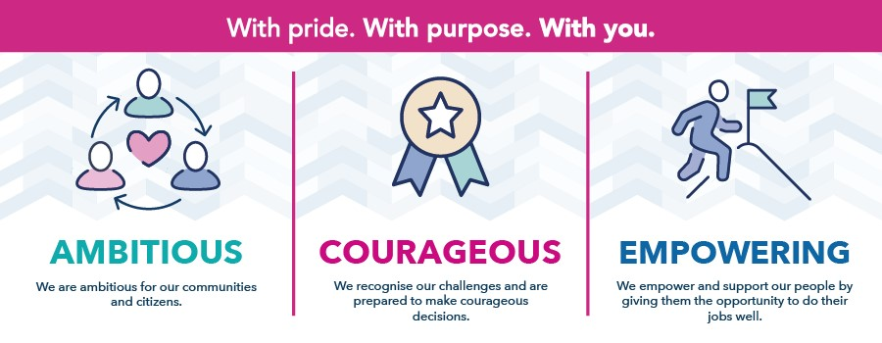

These values are a golden thread through all that we do and underpin our People Strategy so we hope you can see how these values will play a part in the role you’re applying for too!

Contents

# Applying for our roles

All our roles are advertised on our careers website jobs board using our online recruitment platform. For each role we attach the job description and person specification so that you can find out more about the key responsibilities of the role and what skills, experience and / or qualifications you may need.

**03**

## Job description & person specification

The job description will explain to you the key responsibilities of the role and what skills, experience and / or qualifications you may need. The person specification also shows which criteria are essential, shown by the disability confident symbol next to that criteria plus we also call those out in the advert wording as well in the ‘what you’ll bring’ section.

## Disability Confident, Care Leavers & Armed Forces Covenant

If you come under one of these categories (and we’ll ask in your application form to be sure) then we guarantee if you meet the minimum essential criteria for the role that you’ll be shortlisted to interview/assessment stage.

## Our adverts

Within our advert you’ll see a summary of the key things you’ll do in the role along with the essential criteria we’d need you to bring to the role. Where roles can be performed part time, as a job share, hybrid or even via remote working we will indicate this too. However, if it doesn’t say, or you have questions about the role please get in touch with the hiring manager whose contact details will be provided in the advert.

## Filling out your application

We take all applications to our roles through our applicant tracking system for recruitment. When you click to apply you will be prompted to create an account in our recruitment system which tracks all of your applications with us. Depending on the type of role you are applying to you may be able to simply upload your CV to apply or in some instances there may be a need to fully complete an application form with some specific questions.

It’s great if your able to say in your application why you’re suitable for the role. Take a look at the advert wording and job description and let us know which of those essential criteria you’ll bring to the role and anything extra. It’s your chance to tell us why you’ll make a great addition to our team here at Staffordshire and for that role.

**04**

## Managing your candidate profile in our recruitment system

It’s easy to manage your details in our recruitment system. Once you’ve set up your account you can log in at any time to see the progress of your applications and a record of the email communications we have sent to you.

You can also:

* Update your personal details for example if you change address
* Update the newest version of your CV
* Change your GDPR preferences
* Set up job alerts so you get an email when roles you’re interested in get advertised
* Manage your interview bookings
* View your job offer and fill out any related information we have asked for

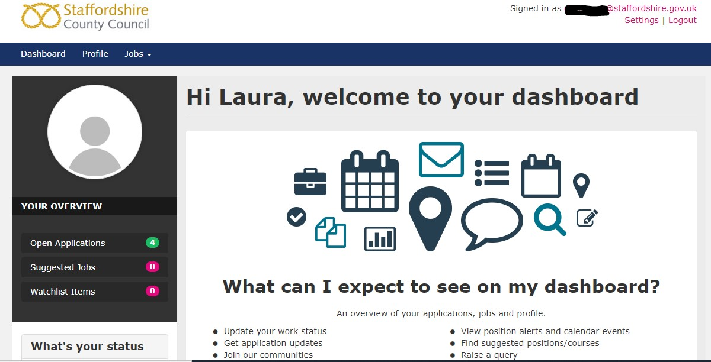

## Account preferences

When you first set up an account with us, we’ll ask you if you want to ‘opt in’ to us being able to contact you. You can also update your preferences after from the settings menu:

**05**

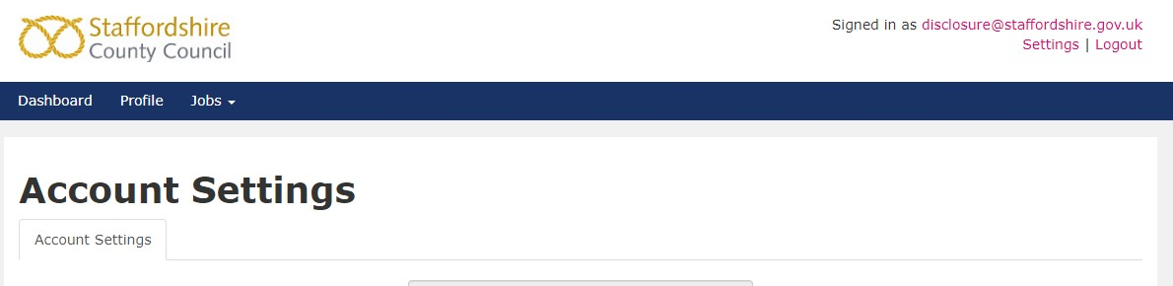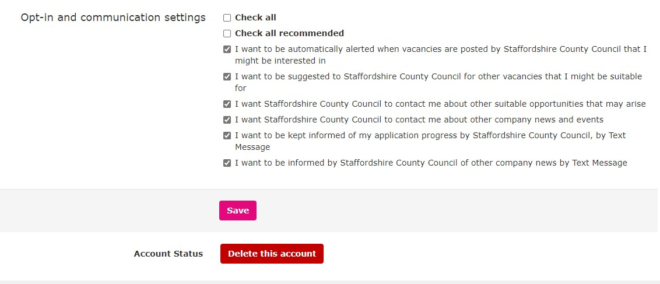

The good thing about opting in means that if ever a role comes up that we think you might be interested in we can then send you a quick email to tell you. Plus, it allows us to keep you updated throughout the recruitment process.

## Equality Monitoring questions

All our applications forms have some equality monitoring questions at the end. We ask these questions so we can look at the demographic of candidates we are attracting and recruiting to our roles. This helps us understand whether we are reaching a diverse candidate pool, reflective of the communities we serve. We’d really appreciate if you would answer these questions and your answers will not be seen by the recruiting manager for the vacancy. This information is for monitoring purposes only. All information will be treated as confidential and will not be used when short-listing or deciding on whether an applicant is suitable for a role.

**06**

## How we we’ll keep in touch with you

Once you have a careers account with us we will primarily contact you via email and often we will prompt you to log into your careers account where you’ll see an easy to navigate dashboard of all your applications. Please ensure the email you have provided to set your account up is correct so we can get in touch with you. Plus, in terms of GDPR legislation there’s a whole section with a link to our privacy policy a bit later on.

## Technical issues or special adjustments

If you do experience any technical issues whilst trying to complete your application or you need adjustments to be able to apply please do get in touch with us at talent@staffordshire.gov.uk and we’ll be happy to support you.

Contents

# Shortlisting

At shortlisting stage the recruiting manager will review all applications against the essential criteria for their role. If a high number of applications are received the recruiting manager may then bring in some of the desirable criteria to be able to come to a suitable short list for the next stage. In some instances, they may request further information from you if it’s unclear whether you meet the essential criteria so do keep a check on the email you have used to apply in case they have tried to get in touch.

Contents

# Interviews and assessment

As with many organisations we tend to do both in person interviews, but we also use Microsoft Teams virtual interviews too if we don’t feel an in-person interview is needed.

## In person interviews

We’ll let you know in your invite where the interview is being held, any local information you might need such as where to park and who to ask for on arrival.

## Microsoft teams interviews

You’ll need MS Teams on your device to be able to join the meeting. You can download MS Teams from your usual App store or via Microsoft on your laptop or PC. You won’t need to pay for the app, just use the free version and you’ll be able to join as a ‘guest’ on your interview day.

**07**

We’ll send the MS Teams invite to the email address you’ve applied to us with.

Then…

1. On the day click on the link which says ‘click here to join the meeting’

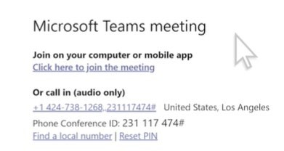

1. Choose from the options, how you want to join. If you’ve downloaded the app you can choose ‘Open in Teams app’ otherwise you can choose ‘continue on this browser’

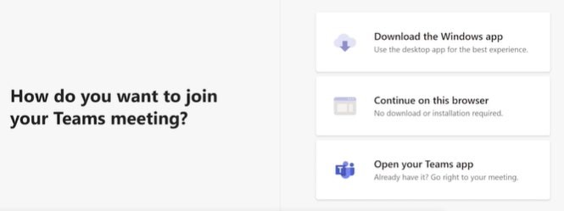

1. You should see your video pop up on the screen and a box to put your name into. Type your name and if your ready click ‘join now’ and wait for the interviewers to admit you to the meeting:

**08**



Here's a helpful link to a video from Microsoft showing you a walkthrough of [how to join teams meetings.](https://support.microsoft.com/en-gb/office/join-a-teams-meeting-078e9868-f1aa-4414-8bb9-ee88e9236ee4)

## Accessibility & Reasonable Adjustments

If you do have any special requirements or need any adjustments to our recruitment process, please do let us know. You’ll find the hiring manager contact details for the role you’ve applied for either in the advert and on your email invites to interview and / or assessment stages so you can get in touch with them in the first instance or for further support please email talent@staffordshire.gov.uk

Contents

# Interviews hints and tips

When you attend an interview or assessment with us we want to give you the best opportunity to show us your skills and experience so we’ve put together a few pointers to help you prepare.

## Plan ahead

* **Where is the interview being held** – if it’s in person, check the route, plan your journey, where will you park. If online, have you got your joining link, are you using a laptop or a phone – is it full charged?

**09**

* **Task, presentation or assessment** – were you asked to prepare a presentation for your interview? Have you been sent an assessment or task to complete? Make sure you check the invite and email to see if there were any other elements to complete or prepare.
* **Things to take with you / have to hand** – were you asked to take documentation? Do you like to ask questions at the interview and perhaps need to take your own notebook? Also having a drink of water to hand can always be good especially as you’ll probably be talking a lot!
* **Review the advert, job description & company website** – it’s always good to remind yourself of the key things the role needs from you and also what the values of the organisation are. This can help you see how you’ll fit into the organisation and which of your skills are going to add the most value for the employer.
* **Practise, practise, practise** – it’s always good to try and predict some of the questions you may get asked and prepare some answers. Try popping these down as bullet point prompts and practise answering some standard interview questions. Also, if you need to have specific technical knowledge, make sure your up to date with your knowledge. A great model for answering interview questions is the STAR model as shown on the following page:

**010 STAR Model**

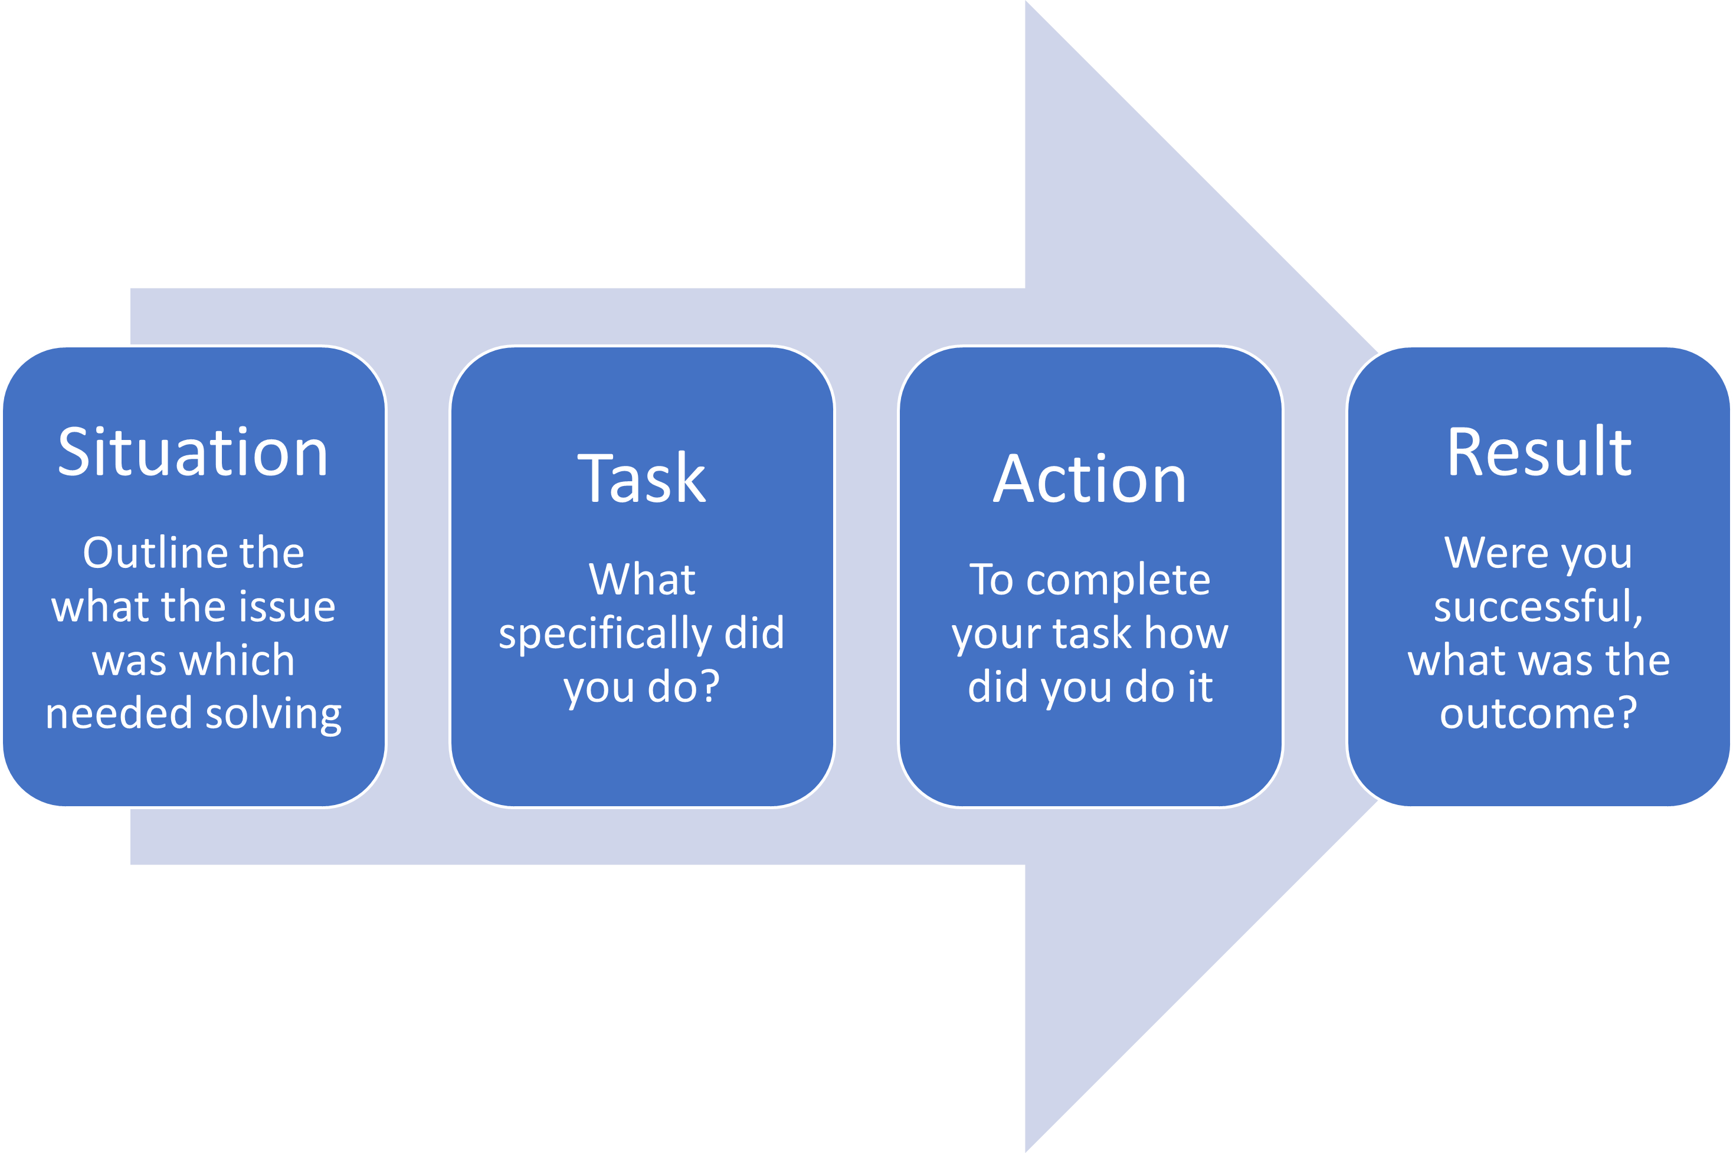

This **STAR Model** gives you a blueprint for covering everything you would need to when answering interview questions or competency questions more generally even in applications forms. It also ensures you draw on examples from real life experience or where that’s not possible follow the steps through STAR and think what you would do in that situation to demonstrate you know what would be needed.

Contents

# Equal Opportunities

We recognise the importance of promoting equality of opportunity across all services as well as in the employment of our staff. We aim to promote equality of opportunity for all with the right mix of talent, skills and potential and we welcome applications from a diverse range of candidates.

Our Equality Policy supports our commitment to promoting inclusion.

**011**

## Disability Confident, Care Leavers & Armed Forces Covenant

If you come under one of these categories (and we’ll ask in your application form to make sure we are aware when shortlisting) then we guarantee if you meet the minimum essential criteria for the role that you’ll be shortlisted to interview/assessment stage.

Contents

## Documentation – Right to work, proof of address, proof of qualification

### Proof of Address

We’ll ask you to provide proof of address during the selection process. Whilst not an exhaustive list, the following **original** documents can be accepted as proof of address:

* Recent utility bill*
* Recent mortgage statement*
* Recent bank/building society statement*
* Current full UK Driving Licence (Paper document)
* Current UK / EU Photocard Driving Licence with Counterpart
* Current house or motor insurance certificate
* Current council tax bill

*dated in the last 3 months

Please note: proof of address cannot be from the same source as “right to work” documentation.

### Proof of Qualification

If applicable and where this is a necessary requirement to be able to perform the role you have applied for we will ask you to provide proof of relevant qualification/s during the selection process.

### Right to Work in the UK

If you are offered the post, we must take copies of evidence that you are able to legally work within the UK; the following list details the acceptable documents/combinations of documents which we must see and copy.

Please bring original documents with you if you are invited to interview.

**012**

**Acceptable Single Documents - List A (only need to be copied once):**

1. A passport showing the holder, or a person named in the passport as the child of the holder, is a British citizen or a citizen of the UK and colonies having the right of abode in the UK; or
2. A passport or national identity card showing that the holder, or a person named in the passport as the child of the holder, is a national of an EEA country or Switzerland; or
3. A Registration Certificate or Document Certifying Permanent Residence issued by the Home Office to a national of an EEA country or Switzerland; or
4. A permanent residence card or document issued by the Home Office to the family member of a national of an EEA country or Switzerland; or
5. A current Biometric Immigration Document (Biometric Residence Permit) issued by the Home Office to the holder indicating that they are allowed to stay indefinitely in the UK or has no time limit on their stay in the UK; or
6. A current passport endorsed to show that the holder is exempt from immigration control, is allowed to stay indefinitely in the UK, has the right of abode in the UK, or has no time limit on their stay in the UK.

1. A current Immigration Status Document issued by the Home Office to the holder with an endorsement indicating that the person named in it is allowed to stay indefinitely in the UK or has no time limit on their stay in the UK together with an official document issued by a previous employer or Government agency with their name and National Insurance number; or

1. A full birth or adoption certificate issued in the UK including the name(s) of the holder’s parent/s together with an official document issued by a previous employer or Government agency with their name and National Insurance number; or

1. A birth or adoption certificate issued in the Channel Islands, the Isle of Man or Ireland together with an official document issued by a previous employer or Government agency with their name and National Insurance number; or

1. A certificate of registration or naturalization as a British citizen together with an official document issued by a previous employer or Government agency with their name and National Insurance number; or

1. A certificate of registration or naturalisation as a British citizen, together with an official document issued by a previous employer or Government agency with their name and National Insurance number.

**013**

**Acceptable Documents List B (need to be copied every 12 months):**

1. A current passport showing they are allowed to stay in the UK and is currently allowed to do the type of work you are offering; or
2. A current Biometric Residence Permit issued by the Home Office to the holder indicating that they can stay in the UK and are allowed to do the work you are offering; or
3. A current residence card (including an Accession Residence Card or Derivative Residence Card) issued by the Home Office to a non-EEA national who is a family member of a national of an EEA country or Switzerland; or
4. A current Immigration Status Document containing a photograph issued by the Home Office to the holder with a valid endorsement indicating that the named person may stay in the UK and is allowed to do the type of work in question, together with an official document giving the person’s permanent National Insurance number and their named issued by a Government agency or a previous employer.
5. A Certificate of Application less than 6 months old issued by the Home

Office to or for the family member of a national of an EEA country or Switzerland stating they are allowed to work together with a positive verification letter from the Home Office’s Employer Checking Service; or

1. An Application Registration Card issued by the Home Office indicating that they are allowed to work together with a positive verification letter from the Home Office’s Employer Checking Service; or
2. A Positive Verification Notice issued by the Home Officer Employer Checking Service to the employer or prospective employer, which indicates that the named person may stay in the UK and is permitted to do the work in question.

Any document/s you provide must be an original and must be provided when requested during the recruitment process.

Contents

# References

Our policy here at Staffordshire is we need to obtain references covering the last five years of your employment (or school/college/university for students). But don’t worry we’ll ask you to provide this information during the recruitment process when we need it.

**014**

You can help us get your referencing completed without delay by making sure you:

* Provide reference details for your full 5 years work history for safeguarding roles, full 3 years for all other roles
* Provide valid contact details for your referees including email address and contact number
* Advise your referees where possible to expect our reference request on email initially

Please note that references from relatives or friends **are not acceptable.**

Contents

# Rehabilitation of Offenders Act

The Rehabilitation of Offenders Act was introduced to make sure that you are not discriminated against when applying for jobs if you have been convicted of a criminal offence and you have not re-offended for a period of time.

The Act allows certain types of convictions to be treated as "spent" after a certain (variable) period of time. You are no longer legally required to disclose to us convictions that have become "spent” unless the post you are applying for is exempted.

Exceptions Orders exist to protect vulnerable groups such as children, young people, and the elderly, sick or disabled. In such cases, we are legally entitled to ask you for details of all convictions, even if they are "spent" or "unspent" under the Rehabilitation of Offenders Act. All details of convictions will be disclosed by the Disclosure and Barring Service (Formerly Criminal Records Bureau) for the preferred candidate.

Cautions, reprimands, and final warnings are not criminal convictions and are not covered by the Rehabilitation of Offenders Act. They become "spent" immediately and we may only consider them when appointing to exempted posts.

All applicants who are offered employment to a post, subject to a criminal record check from the Disclosure and Barring Service (formerly Criminal Records Bureau) before the appointment is confirmed, will have to provide details of cautions, reprimands, or final warnings, as well as convictions.

Having an “unspent” conviction will not necessarily bar you from employment. This will depend on the circumstances and background to your offence(s).

A conviction is regarded as spent if you have served a 'rehabilitation period'.

These periods vary according to the sentence received as follows: -

**015**

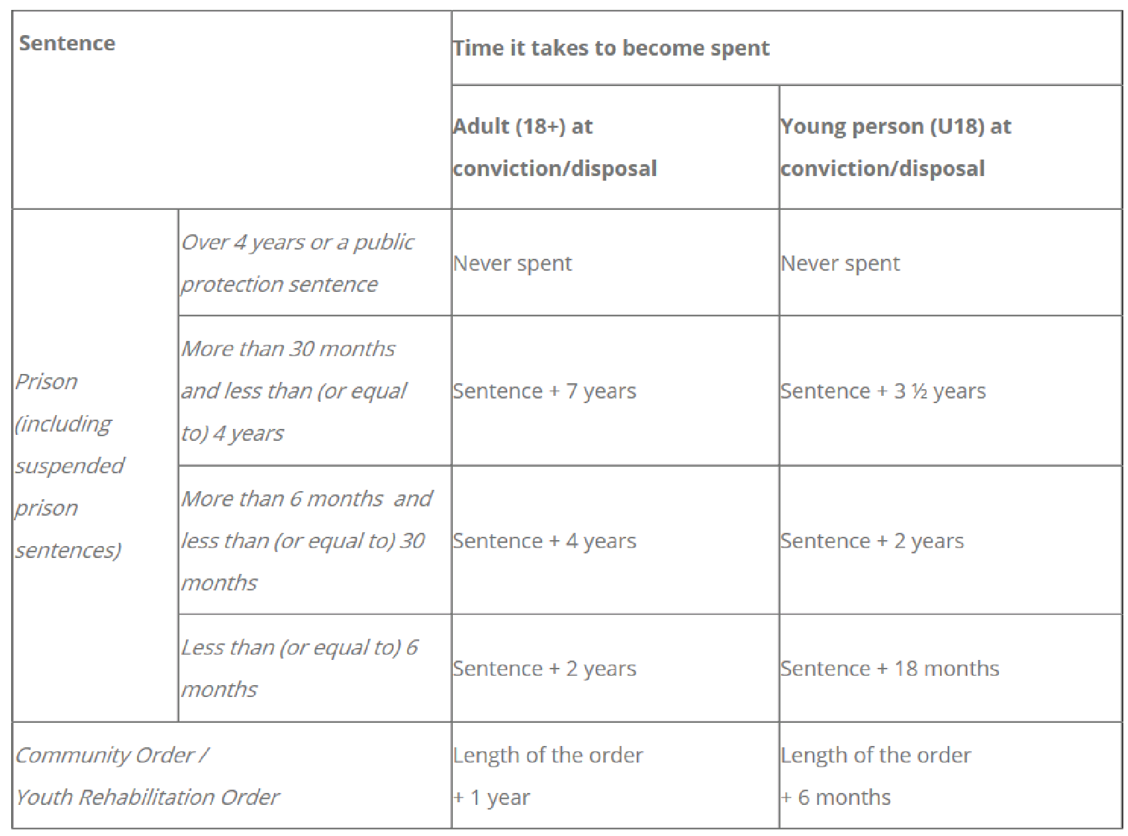

Contents

# Safer Recruitment

Staffordshire County Council provides services to some of the most vulnerable residents in the county. We are required to ensure that the confidentiality and safety of our service users is protected, and we therefore undertake the most stringent vetting of our staff. This includes, where appropriate, Criminal Record Checks and thorough referencing, scrutiny of previous employment history and checks against our client and employee records.

A trace against these does not mean that applicants are unsuitable for employment. It does, however, allow us to explore and address any potential conflicts of interest and also to assess suitability for employment.

Submitting your application form indicates your consent for such checks to be undertaken.

Contents

# GDPR

Data Protection Legislation places responsibilities on us to process personal data that we hold in a fair and proper way.

**016**

We collect personal information from you when you register with us to make any application. Information we collect includes name, email address and other contact details. We will use this information to communicate with you generally and to assess your application.

The personal data supplied in your job application will be used for recruitment and selection purposes and if appointed to the job any subsequent personal information provided throughout the course of your employment, including sensitive personal data (e.g., medical health, criminal convictions, references etc.) will be held and processed for employment purposes by the Council and any third-party organisations that provide services on our behalf. Any organisations that process your personal data on behalf of the County Council have the same legal obligation to comply with data protection legislation.

Personal information relating to your application will be kept in secure conditions. If you are unsuccessful, your personal data will normally be destroyed after 1 year. If you are successful, the data will be retained both for the duration of your employment and for a period after in line with our retention and disposal schedule.

Further details on how we process your personal data is available in our [Privacy Notice](https://www.staffordshire.gov.uk/yourcouncil/requestandaccessinformation/Council-information/How-we-manage-information/How-We-Handle-Personal-Information/Privacy-Notice.aspx)

We will consider that, by submitting your application form, you are giving your consent to the processing of your personal data in the ways described above.

Contents

# Politically Restricted Roles

A small number of roles we recruit to are classed as politically restricted and so this means the successful candidate cannot be an elected member of local authorities, an MP or MEP as stated in ‘The Local Government and Housing Act 1989’. Where a role is politically restricted, we will state this in the advert/JD to make you aware.

Contents

# Relationship to members / employees canvassing

To ensure fairness in our recruitment process we ask in our application form whether you are related to a Member, or Officer, of Staffordshire County Council.

**017**

We will not be able to appoint you if you canvass any Members/Officers of the County or of any committee of the Council, directly or indirectly – this means asking for help and influence to get a job using their position in the council.

Contents

# Cabinet Office Fair Processing Protocol

The Authority is under a duty to protect the funds it administers and to this end may use the information you have provided as part of the recruitment process for the prevention and detection of fraud. It may also share this information with other bodies responsible for auditing or administering public funds for these purposes.

As part of this ongoing responsibility Staffordshire County Council participates in the Cabinet Office National Fraud Initiative every two years. Key payroll and other data is used in a matching exercise to identify frauds, data errors etc; For further information please visit [www.staffordshire.gov.uk/nfi.](http://www.staffordshire.gov.uk/nfi)

Contents