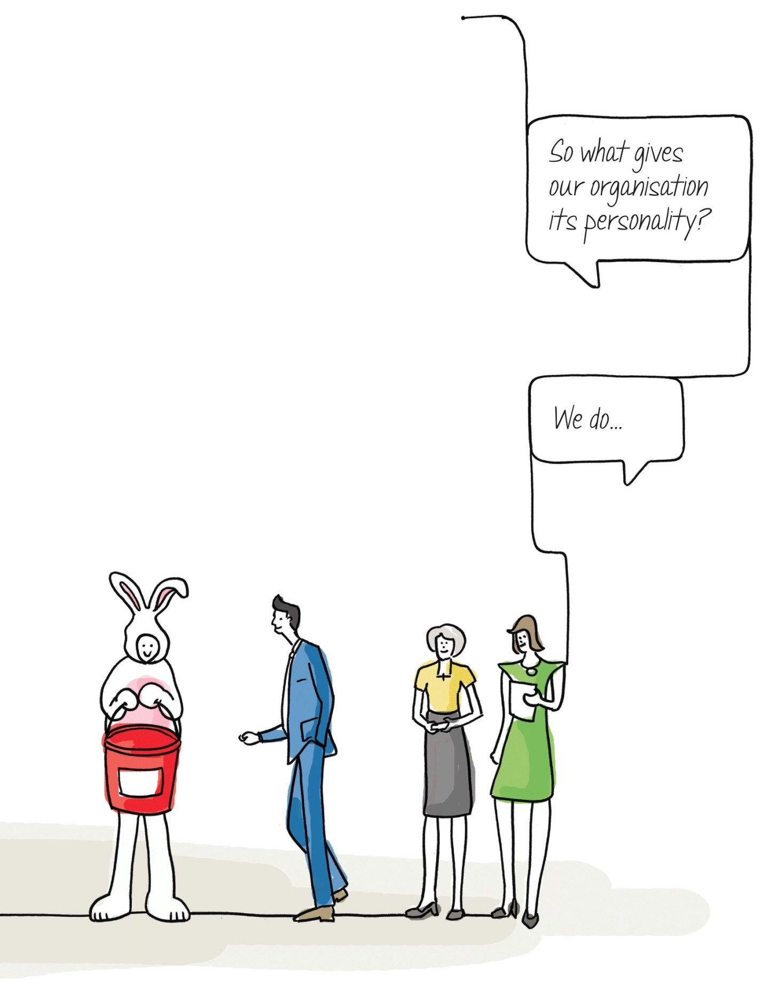

**EDUCATION WELFARE WORKER**

FAMILIES AND COMMUNITIES

|  |  |  |
| --- | --- | --- |
| **Families & Communities** | | |
| **Post Title** | **Grade** | **Role Type** |
| **Education Welfare Officer** | 8 | B |

**Our Vision -** Is for a connected Staffordshire, where everyone has the opportunity to prosper, be healthy and happy.

**Our Outcomes -** The people of Staffordshire will:

* Be able to access more good jobs and feel the benefit of economic growth
* Be healthier and more independent
* Feel safer, happier and more supported in and by their community

**About the Service**

Insight has evidenced that Staffordshire is a great place to live. Most families are happy, safe and have loving homes, however there are some families who face challenges that mean they cannot thrive in the way they want to.

We are committed to developing a system and a way of working that will enable Staffordshire’s children to thrive within their own families and communities by addressing the root causes of difficulties for the whole family at the earliest point.

Staffordshire’s Children’s Service aims to:

1. Maximise the achievement of better outcomes for families in Staffordshire using all available resources, effectively and efficiently.
2. Support safer, healthier, thriving children whose needs are met within their families and communities where it is safe to do so, reducing the need for higher cost, complex interventions.
3. Provide high quality statutory Children’s Service (Staffordshire County Council’s children’s services are currently rated as “Good” by Ofsted) that only works with those children and families who require this specialist level of intervention.

Our commissioning is focused upon reducing demand. We recognise that our commissioning must be evidenced based and future focused. Whilst the service within the cusp of statutory care is dealing with the issues that are presenting today we expect to commission services, relationships and practice smartly to prevent those issues presenting in the future.

# Reporting Relationships

**Responsible to: Education Welfare Lead & Family Practitioner Lead (Matrix management)**

**About this role**

To provide an education welfare service for children, their families and schools. , in conjunction with others, to ensure that parents in turn ensure that their children receive education appropriate to their needs by regular attendance at school or otherwise and to assist them to obtain maximum benefit from this education.

To ensure that all Local Authority statutory requirements are appropriately met.

**Key Accountabilities:**

|  |  |
| --- | --- |
| * To act as children’s education advocate and to facilitate the educational partnership between home, school, community and Local Authority, by support, liaison and negotiation; and where conflict arises to give paramount consideration to the interests of the child. | |
|  | |
| * To support and under the direction of the Education Welfare Lead **/**Principal Officer – Attendance and Inclusion take statutory action over non-attendance cases when necessary, including presentation of cases in court, under the Education Act 1996 and the Children Act 1989; and to be the designated supervisor for Education Supervision Orders. * Inspection of maintained school registers as required. * To support and under the direction of the Education Welfare Lead **/**Principal Officer – Attendance and Inclusion, take statutory action for the Local Authority in delivering its statutory functions with regard to Elective Home Education and Children Missing Education. * Support the Local Authority in the delivery of its functions regarding children missing education * To participate in the delivery of child entertainment and employment statutory functions of the Local Authority, undertaking site visits and promoting the safeguarding and welfare of children. | |
| * To advise and support schools in the implementation of School Attendance Regulations | |
|  | |
|  | |
|  | |
| * To participate in child protection procedures, as appropriate, including making Education Welfare Worker contribution to the design and implementation of child protection plans. * Support the Local Authorities Education Safeguarding Officer to review school’s response to meeting their safeguarding responsibilities, and support the implementation of improvements where these are identified as necessary * To contribute to “Team Around the Child” Early Help activity where appropriate. | |
|  | |
|  | |
|  | |
|  | |
| * Acquire knowledge/expertise in agreed specialist area(s) of education practice as agreed withCoordinator **/**Service Manager Targeted Services in Education * To participate in the screening of referrals at First Response, to identify children and young peoples with educational needs | |
|  | |
|  | |
| * To maintain all appropriate records, prepare assessments and reports; and provide statistics as required. | |
|  | |
|  | |
| * The post holder will carry out any other reasonable duties within the overall function commensurate with the grading and level of responsibilities of the post. | |
|  | |

|  |
| --- |
|  |
|  |

|  |
| --- |
|  |
|  |

|  |
| --- |
|  |
|  |

|  |
| --- |
|  |
|  |

# Professional Accountabilities

The post holder is required to contribute to the achievement of the Council objectives through:

# Financial Management

* Personally accountable for delivering services efficiently, effectively, within budget and to implement any approved savings and investment allocated to the service area.

# People Management

* Participation and contribution in the Personal Performance Review process.

# Equalities

* Ensure that all work is completed with a commitment to equality and anti- discriminatory practice, as a minimum to standards required by legislation.

# Climate Change

* Delivering energy conservation practices in line with the County Council’s corporate climate change strategy.

# Health and Safety

* Ensure a work environment that protects people’s health and safety and that promotes welfare and which is in accordance with the County Council Health & Safety policy.

# Safeguarding

* To be committed to safe guarding and promoting the welfare of children and young people/vulnerable adults.

The content of this job description and person specification will be reviewed on a regular basis

**Person Specification** A = Assessed at Application I = Assessed at Interview T= Test

|  |  |  |
| --- | --- | --- |
| **Minimum Criteria for Disability Confident Scheme** | **Criteria** | **Measured by** |
| **employer_small**  **employer_small** | **Qualifications/Professional membership**   * Significant experience of education/ welfare and working with schools. * Minimum standard of NVQ 3 in respect of working with children and their families or equivalent. | A  A |
| **employer_small**  **employer_smallemployer_smallemployer_small**  **employer_small** | **Experience and Knowledge**   * A detailed knowledge of the Education Welfare role and responsibilities, including associated legislation and statutory responsibilities * Demonstrate an understanding of effective challenge to discriminatory or inappropriate behaviour within families and agencies. * An understanding of, and ability to comply with, Safeguarding Procedures. * An understanding of the key pieces of legislation which govern children’s safeguarding, welfare in education. * An understanding and experience of multi-agency working. * Knowledge of partners, agencies and their role in supporting families. * Knowledge and ability to undertake assessments and make appropriate decisions, in line with professional accountability. * Knowledge of mental health, substance misuse, domestic abuse, poverty and other vulnerabilities and how these impact on school attendance and attainment. * Detailed knowledge of the education system. * Must be able to work independently although part of a team. * Must have a desire to help children to take full advantage of the educational opportunities available. * A desire to help young people and parents to identify, address and resolve their problems and to guide them to change in attitude. * An understanding of how to appropriately signpost or intervene with those families with identified unmet needs.   **Skills**   * Must be able to organise own daily work routine and manage a personal caseload; this may include work outside the normal Flexible Working Hours Scheme. * Must have good written and oral communication skills appropriate to both adults and children; ability to write clear, concise reports; human relationship skills; * Familiarity with computers and a level of computer skills to operate a database and word processing. * A demonstrable ability to maintain all appropriate records * Prepare assessments and reports; and provide statistics as required. | A&I  I  A&I  A&I  A  A&I  A&I  I  I  I  A  A&I  I  I  A&I  A  A  I |

**employer_small** If a disabled person meets the criteria indicated by the Disability Confident scheme symbol and provides evidence of this on their application form they will be guaranteed an interview.

We are proud to display the **Disability Confidence Symbol,** which is a recognition given by Job Centre plus to employers who agree to meet specific requirements regarding the recruitment, employment, retention and career development of disabled people.

If you need a copy of this information in large print, Braille, another language, on cassette or disc, please ask us by contacting the **Recruitment Team on 01785 276113**