Policy and Insight Officer – Grade 7 - £27,803 to £31,364 per annum
37 Hours per week – Permanent
Job Introduction
Do you want to be at the heart of helping to drive forward Staffordshire County Council’s priorities, and improving outcomes for the people of Staffordshire? Are you inquisitive, analytical, and able to communicate compellingly?

If so, we have an exciting opportunity to be part of the council’s corporate Policy and Insight Team as a Policy and Insight Officer. In this role you will have the opportunity to support the delivery of the policy and insight work programme, that directly influences and shapes strategy and decision-making both in the council and across the wider Staffordshire partnership. You will be part of an ambitious, fast paced team, which will involve working with Research Leads, Senior Researchers and Policy Officers, contributing to the design, development and delivery of a range of insight and public policy projects. In addition, the role will entail exploring opportunities and coming up with new ideas that will help to positively respond to the challenges facing local public services.

Main Responsibility

As part of a dynamic corporate Policy and Insight Team at the heart of shaping strategy across the council, this role will support across a range of important projects, that contribute to the effective delivery of the team’s priorities. This will include sourcing and managing various datasets and information, such as research, analysis and public policy, as well as aiding in planning, written briefings, supporting events and a range of influencing activities. You will also lead on a range of smaller research or policy projects, aligned to the work programme, whilst developing positive stakeholder relationships relevant to the work.

The ideal candidate
With further information in the Job description, you will bring:

- The initiative to manage and prioritise your own workload, responding flexibly to changing needs and priorities, with conflicting demands and pressures.

- Practical experience within a local government or related policy and insight field– with an appetite to learn.

- Experience and knowledge of using a range of insight tools and techniques, for both qualitative and quantitative research purposes.

- Strong research and analytical skills, utilising diverse data sources (e.g., citizen feedback, qualitative data, policy guidance, service performance data etc), and ability to deliver tailored outputs for target audiences.

- Ability to represent the Team, where appropriate, at internal or external forums, and to work effectively with colleagues across the business, and partners.

But above all else you’ll have a passion for public services, demonstrable experience of contributing to the delivery of high-quality policy and insight activity and outputs, along with being a flexible, dynamic professional with great research, analytical and communication skills.
Closing Date: 2 July 2024
Interviews: Anticipated to take place on the week commencing 8th July on Microsoft Teams (date / arrangements may be subject to change)

How we work
We work flexibly with a mix of office and home working to make sure we can all have a great work life balance and informed by business need. If you’d like to find out more about the role get in touch with: Keith Luscombe, Strategic Policy and Partnerships Manager, E: keith.luscombe@staffordshire.gov.uk

About Staffordshire County Council
We are no ordinary county council:
Our Values:
The core of who we are as an organisation. Just like we all have personal values that shape our thoughts and behaviour, organisational values drive how we think and act collectively.
Our values were created and shaped by colleague feedback and national best practice and they sit at the heart of People Strategy:
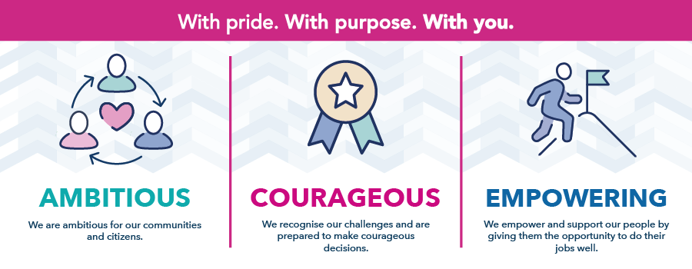
We have a real sense of community spirit that brings our people together. This feeling of belonging means we are all connected to what we do and take pride in the difference we make every day for Staffordshire people. We are ambitious and our sights are set firmly on a better future.
We look forward and race ahead - that goes for your career too.
Our benefits:
We recognise that it is our employees that are central to everything we do. We aim to create a supportive working environment where employees can achieve their full potential and achieve a healthy work-life balance.
In addition to your salary, as a member of staff, you will have access to a range of benefits.
Our recruitment process:
As an Authority we are committed to safeguarding and promoting the welfare of children and young people/vulnerable adults and expect all staff and volunteers to share this commitment.
Staffordshire County Council is an equal opportunities organisation and Disability Confident employer. We encourage applications from all background and communities
As part of our commitment as a Disability Confident employer, a Silver Award Armed Forces employer and our commitment to supporting care leavers - we offer a guaranteed interview as long as your application meets the minimum criteria for the post.

